A Novel Algorithm for Computational Identification of Contaminated EST Libraries
Rotem Sorek and Hershel M. Safer
Nucleic Acids Research, Vol. 31, No. 3, pp. 1067-1074, 2003
Abstract
A key goal of the Human Genome Project was to understand the complete set of human proteins, the proteome. Since the genome sequence by itself is not sufficient for predicting new genes and alternative splicing events that lead to new proteins, expressed sequence tags (ESTs) are used as the primary tool for these purposes. Here we describe a novel method for recognizing genomic DNA contamination and other artifacts that cannot be identified using current EST cleaning techniques. Our method uses the alignment of the entire set of ESTs to the human genome to identify highly contamination EST libraries. Conclusions based on EST analysis, including prediction of alternative splicing, should be re-evaluated in light of these results.
- Introduction
A typical collection of ESTs is highly redundant, so an early step in gene structure analysis is generally to group, or cluster, the ESTs based on sequence overlaps. A major obstacle to correct gene identification is the high error rate in EST datasets.
- Materials and Methods
Our analyses were based on examining gene structure and splice variants, as predicted from alignment of human ESTs to the Human genome. ESTs were from dbEST, GenBank version 126, which contained almost 3.86 million human EST sequences.
- Results
- Human genomic DNA contamination
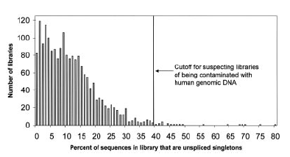
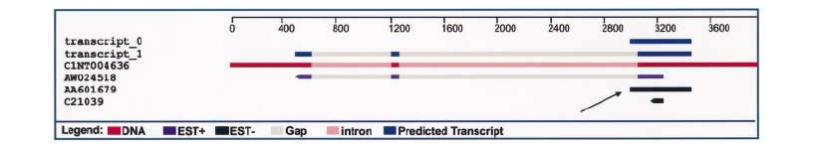
- Pre-mRNA contamination
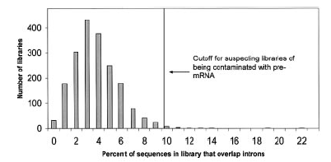
- Non-canonical introns
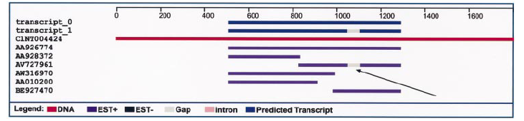

Created by : Chia-Chang Wang
Date : April 22, 2004

